**D.Y. PATIL COLLEGE OF ENGINEERING &**

**TECHNOLOGY,**

**KASABA BAWADA, KOLHAPUR**

**DEPARTMENT OF COMPUTER SCIENCE & ENGINEERING**

**(2020-2021)**



**A**

**Mini Project**

**Report on**

**“Hotel Room Management”**

**Submitted by:**

**Roll No Name of student**

**50 ANUSHA SHARAD SHINDE**

**51 GAURI PANKAJ PARKHE**

**52 SNEHANJALI PRAMOD PATIL**

**53 PRANALI VIKAS PATIL**

**Under the guidance of**

**Guide Name – R.S. Jadhav**

**Class: SY (CSE)**

**D.Y. PATIL COLLEGE OF ENGINEERING &**

**TECHNOLOGY**

**DEPARTMENT OF COMPUTER SCIENCE & ENGINEERING**

**KOLHAPUR**



**CERTIFICATE**

This is to certify that mini project group consisting the following members have satisfactorily completed the Mini Project work entitled **“Hotel Room Management”** at SE (CSE) semester IV as prescribed in the syllabus of Shivaji University for the academic year 2020-2021

**Name Exam seat number**

**ANUSHA SHARAD SHINDE**

**GAURI PANKAJ PARKHE**

**SNEHANJALI PRAMOD PATIL**

**PRANALI VIKAS PATIL**

**Date:**

**Place:** Kolhapur

**( Project Guide ) Prof. Dr. K.V. Kulhali**

**(HOD)**

**( Mrs. R. S. Jadhav ) Prof. Dr A. N. Jadhav**

**( Project coordinator ) ( Principal )**

**External Examiner**

**ACKNOWLEDGEMENT**

This project is work entitled **“Hotel Room Management”** was a formidable task, but with collective effort of our group and active guidance made it possible for us to complete.

First of all we would like to thank Prof. Dr. K. V. Kulhalli ( H.O.D., Department of computer science and engineering ) delineating us with project work.

We would also like to thank her for the support and interest that the shown in bringing out this project and our course co-ordinator Prof. R. S. Jadhav for their guidance and cooperation. We would like to express our most humble and deepest gratitude to Guide Name, for providing us with right guidance at the time of need it was for his presence and active guidance that we were able to complete the project work.

We would like to thank all our friends for their help, ideas, criticisms and also their encouragement for preparation of this project work. Any further ideas and constructive criticisms on our work shall be highly welcomed.

**Date:**

**Place:** Kolhapur

**Name Sign**

**ANUSHA SHARAD SHINDE**

**GAURI PANKAJ PARKHE**

**SNEHANJALI PRAMOD PATIL**

**PRANALI VIKAS PATIL**

**Div.:** **A** **Batch:** **G13**

**INDEX**

* **Introduction**
* **Problem Statement**
* **Objectives**
* **Control Flow Diagram with explanation**
* **Algorithm / Pseudo Code (implementation steps )**
* **Functions and constructs**
* **System requirement (Hardware and software requirement )**
* **Input/Output**
* **Conclusion**
* **Reference**

**Project Coordinator HOD**

**(CSE)**

**1. INTRODUCTION**

The hotel room management system is to generalize and simply the monthly or day to day activities of Hotel like Room activities, Check in of New customer, Check out of customer, Assigning a room according to customer requirement, and finally compute the bill etc. which has to be performed repeatedly on regular basis. To provide efficient, fast reliable and user- friendly system is the basic motto behind this exercise. And show the Hotel room facilities, Book room. The main aim of the entire activity is to automate the process of the day to day activities of Hotel like Room activities, Admission of a new customer, Assign a room according to customer’s demand, checkout of a computer and releasing the room, we can search the details of the guest according to the room number & name, we are also providing the facility of making booking request.

**2. PROBLEM STATEMENT**

To show the detailed information about HotelManagement System using database Management.

**3.OBJECTIVES**

1. Hotel Management System provides room booking and other necessary hotel management features. The system allows the admin to check available room in the system. Customer can view and room online. Admin can approve or reject booking request.

1. To avoid manual and repetitive work.
2. Improving decision making.
3. Real time information of availability of rooms.

**CONTROL FLOW DIAGRAM**

1. **For admin**

WELCOME TO SYSTEM

CHOOSE ADMIN OR USER

**IF USER**

**IF ADMIN IF FALSE**

ALERT MESSAGE

PASS

**IF TRUE**

ASK FUN

ADD TIME OF LEAVING OR COMING

SEARCHING ACCORDING TO NAME OR ROOM NUMBER

DO CHECKOUT

MAKE BOOKING

VIEW ROOMS

VEW BOOKING REQUEST

**IF NO**

IF WANT TO CONTINUE

**IF YES**

1. **For user**

WELCOME TO SYSTEM

CHOOSE USER OR ADMIN

**IF ADMIN**

**IF USER**

ASK FUN

ADD TIME TO LEAVING OR COMING

VIEW AVAILABLE ROOM

MAKE BOOKING REQUEST

IF YOU WANT TO CONTINUE

**IF NO**

**IF YES**

**ALGORITHM:**

1. Welcome the user or admin.
2. Select 1 for admin & 2 for user
3. If it is user
4. Display the function.
5. Take a choice & implement switch statement
6. Make a function call according to choice
7. If user wants to continue go to step 4
8. Else end the program
9. Else it is admin
10. If password is correct
11. Display the function
12. Take a choice & implement switch statement
13. Make a function call according to choice
14. If admin wants to continue go to step 10
15. Else end the program
16. Else password is wrong
17. End the program

**EXPLANATION :**

In this project the main aim is to provide application which do all the functions which are related to the rooms of the hotel. It helps to make booking, do the checkout, search the guest, maintain the record of entering & leaving from hotel.

**Designing modules of Hotel Room Management:**

The software architecture consists of the following modules:-

**Module 1:** ( Header & declaring functions global variables )

This module will include the necessary header files, also here functions will be declared some global variable such as file pointer, structure is also declared

**Module 2:** (main function)

In this module the main function is defined. In that welcoming to system and some validations for the user & admin is done. According to the cases functions are called here.

**Module 3:** (view rooms)

Here the available rooms are get displayed

**Module 4:** ( make booking request)

Here booking request is done by the user.

**Module 5:** (add time)

In this module the time of leaving and coming is added.

**Module 6:** (view booking request)

Here the booking request of the user are getting displayed.

**Module 7:** (make booking)

In this module booking done by the admin.

**Module 8:** (checkout user )

In this module the checkout of the guest is done.

**Module 9:** (searching guest)

In this module the guest is searched using the name or room number by the admin.

**FEATURES:**

* Making booking requests
* Making booking
* Doing check out
* Searching guest using name
* Searching guest using room numbers
* View available rooms
* View available rooms
* Check out coming leaving time of guests

1. **SYSTEM REQUIREMENT:**

**Hardware requirement:**

* **Processor:** intel ® core™ i4- 3240
* **CPU:** 3.40 GHz
* **RAM:** Minimum 512 MB
* **System Type:** 32bit operating system

**Software Requirement:**

* Windows text editor and online compiler
* C programming (function oriented)

1. **INPUT AND OUTPUT**

**Input:**

* The 1st input is taken to choose whether it is user or admin
* The 2nd input is taken to choose the function depending onto the user or admin
* The 3rd input is for the data or information which is needed for the function

**Output:**

* Into the output section user or admin get the output depending onto the function which they have chosen. For this output user or admin have to provide same data or command also.

**Sample Input:**

1. Choose whether it is admin or user
2. View plan and available room command
3. Making booking request
4. Adding time of leaving and coming
5. View booking request command
6. Making a booking
7. Searching the guest using the name
8. Searching the guest using the room
9. Doing a checkout.

**Sample Output:**

1. **Choose whether it is admin or user**

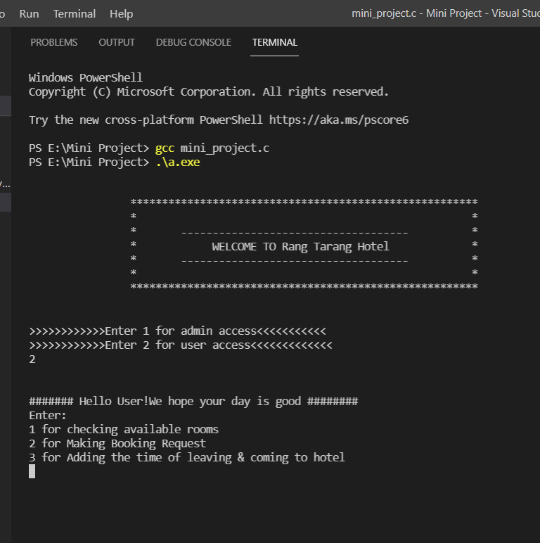

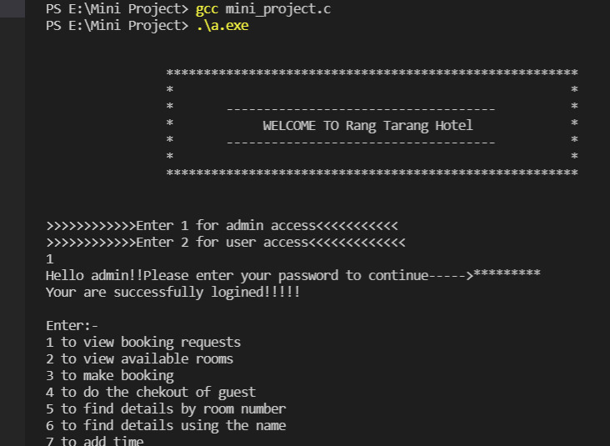

1. **View plan and available rooms**

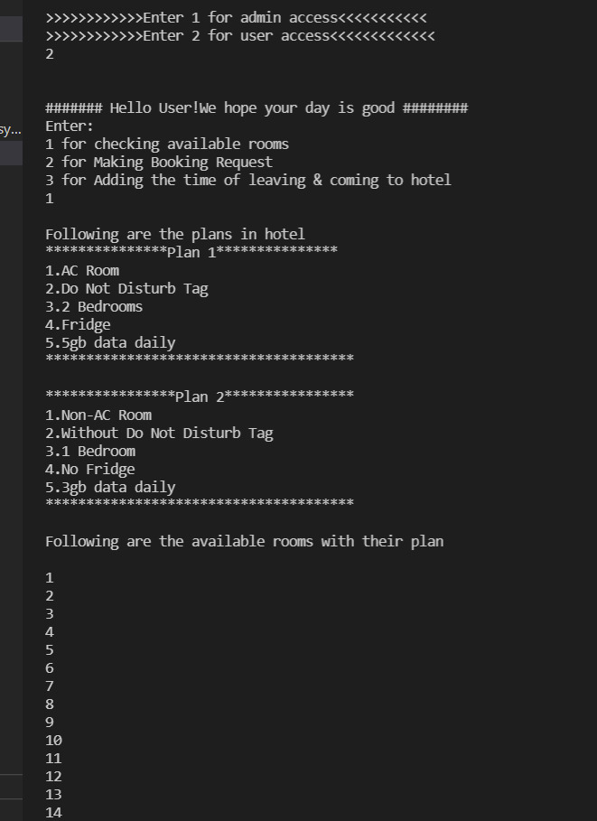

1. **Making booking request**

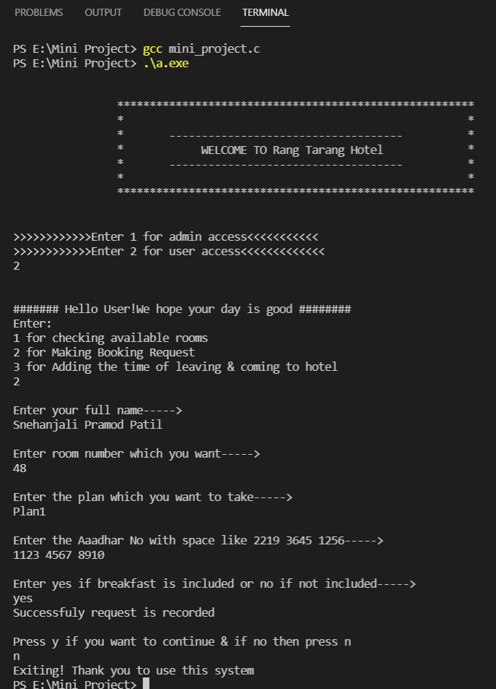

1. **Adding time of leaving and coming**

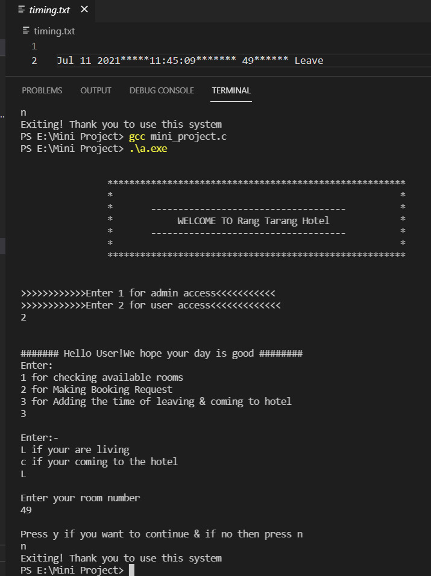

1. **View booking request command**

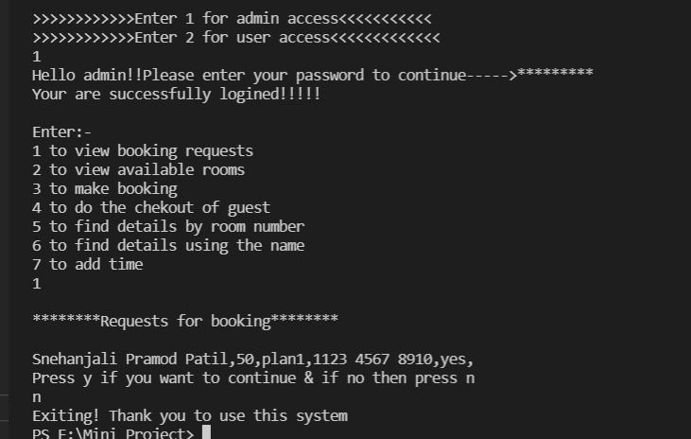

1. **Making a booking**

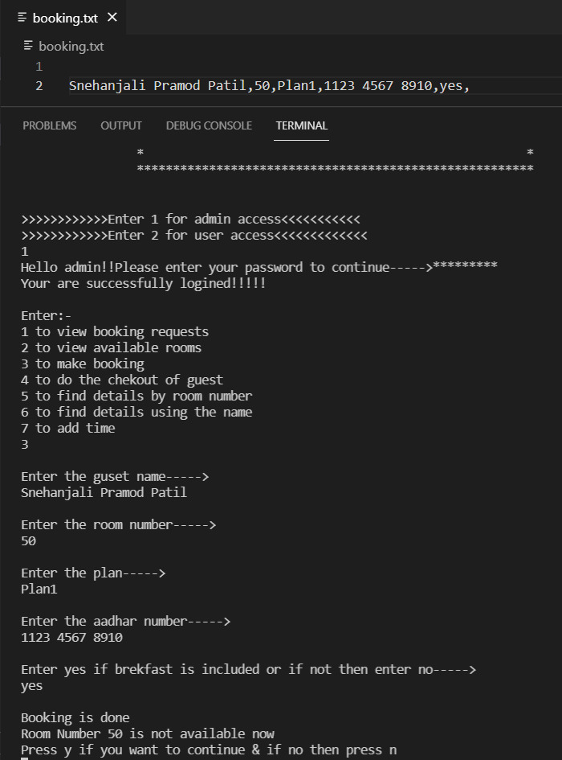

1. **Searching the guest using the name**

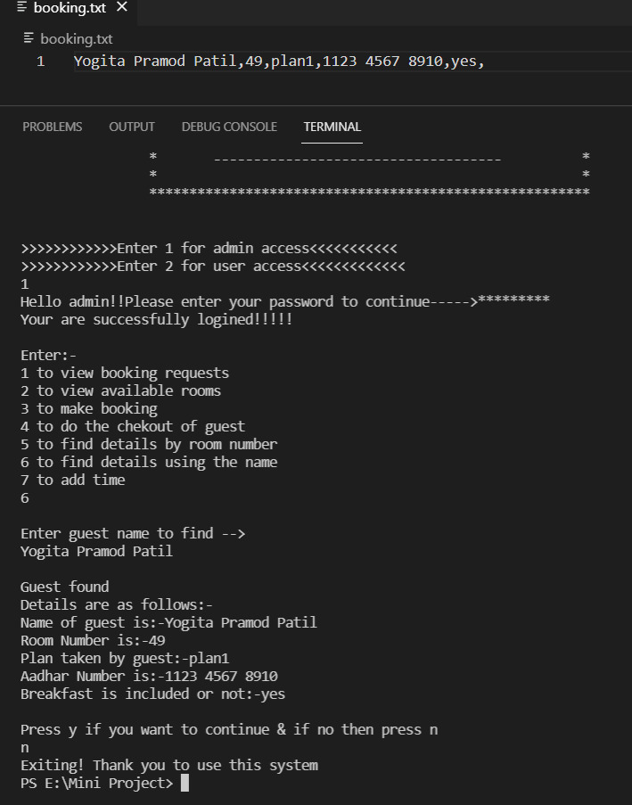

1. **Searching the guest using the room**

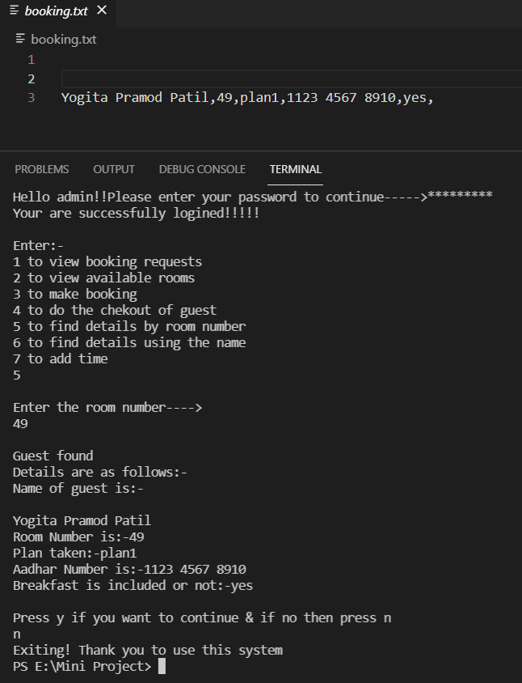

1. **Doing a checkout.**

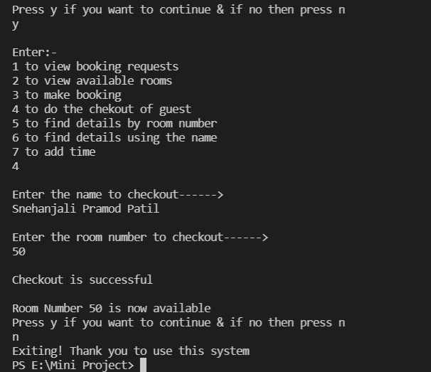

1. **CONCLUSION:**

* While developing this project we have learnt a lot about hotel management.
* The online hotel management system was developed to replace the manual process of booking for a hotel room or any other facility of the hotel.
* The old system does not serve the customer in a better way; rather it makes customer data vulnerable.
* The new system keeps proper records of customers for emergency and security purposes.
* We learnt how to make a system user friendly.
* During the development process we studied carefully and understood the criteria of implementation process.

Finally, we can say that this project performs in its best possible manner in order to expedite daily activities of a hotel.

1. **REFERENCE:**

* Books: Let Us C By Yashavant P. Kanetkar, 8th Edition.